ACTIVITIES - 12/05/15
DISCLAIMER: Toni Nelson and the IOE ORGANISATION take no responsibility for any personal injury, out of pocket expenses or anything else arising from activities you may attend. This is just a guide as to what’s on and has simply been copied and pasted from various sites. Thank you.
CURE BRAIN CANCER FOUNDATION
www.curebraincancer.org.au

Dine For A Cure - One Thousand Cranes 2015 Gala Dinner
Contact:
Hamish Park
0403 169 364
info@dineforacure.org
Join Dine For A Cure for the fourth annual One Thousand Cranes Gala Dinner on Friday 29 May at Crown Palladium, Melbourne.

Dine with Charlie Teo, groove with Tim Campbell, enjoy a delicious three-course meal with wines, be in the running to win luxury prizes and help us raise crucial funds for brain cancer research.
Location: Crown Palladium, Crown Casino, Melbourne
Charlie Teo really is THE most amazing Surgeon: he has operated on and saved many people whose own Surgeons refused to take the risk.) .

Date: May 29 2015
Guest speaker: A/Prof Charlie Teo 
(Tickets: $195 per head, or buy a table of 10 and receive the 11th ticket free. Tickets on sale now via info@dineforacure.org. They are also having an amazing raffle.

A BIT TOO PRICEY? THEN, HOW ABOUT THIS:

CHECK OUT THEIR MERCHANDISE
OR
1300 362 965 to donate ☺

- $25 educates 5 teachers about early detection
- $50 funds a nurse to enrol a patient on a clinical aid
- $400 funds a day’s lab research (1 researcher)
- $2000 funds genetic sequencing of a patient’s tumour

Donate to Cure Brain Cancer: Brain cancer kills more children than any other disease. Our mission is to increase five-year survival to 50% within 10 years by funding vital research for both adults and children
THE RSPCA MILLION PAWS WALK:
Why? To fight against Animal Cruelty
When: May 17th 2015
Phone: 03 9224 2222
Website: www.millionpawswalk.com.au/Victoria.htm
Where: Various Locations
Cost: Varying. Costs on their Website
Take a stand against cruelty to animals and help our furry four legged buddies.
This is your chance to make a stand and to take your pal with you on a walk that not only will be an enjoyable experience for you both but you will be helping to raise much needed funding to fight against animal cruelty by joining in on the Million Paws Walk on May 17th. This is the RSPCA's biggest fundraising event.
You will be able to set up your own fundraising page which is a great way to make every step count.
These loyal companions need our voice to help stop senseless cruelty, so please gather your family and friends and register to participate to take part in this worthwhile cause.
IT’S OPEN DAY @ TARALEIGH PRE-SCHOOL (STEINER SCHOOL)

When: 10am - 2pm, Saturday May 23
Website: www.taraleighpreschool.org
Where: 90 Bignell Road, Bentleigh East
Cost: Free
BIRDS OF A FEATHER (CONCERT)
Queen's College is playing host to Birds of a Feather, a one-night only event featuring performances from celebrated poet, Anne M Carson, accomplished British harpist, Vanessa McKeand and local singer & pianist, Julian Bailey.
When: Sunday 17 May 2015 5:00pm – 6:30pm
Where: JCR, Queen's College, Parkville, Melbourne
Cost: Full $40 / Concession $30

SPICY SECHUAN DINING IN BOURKE STREET
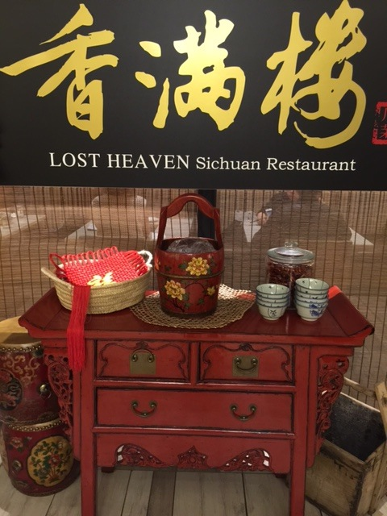

Why? For a spicy take of Chinese dining
When: Monday – Sunday: 11.30am – 3.00pm (Lunch) Sunday – Thursday: 5.30pm – 11.00pm (Dinner) Late night supper available Friday and Saturday nights
Phone: 9650 2188
Website: www.lostheaven.com.au
Where: Level 2, 206 Bourke Street, Melbourne
AIDS INTERNATIONAL CANDLELIGHT MEMORIAL


Why? Support an important cause
When: Sunday 17th May, 2015
Website: www.candlelightmemorial.org/news/item/107-2015-candlelight-memorial-theme-calls-on-leaders-to-support-the-future-of-people-living-with-hiv
Where: City Square
Cost: Free
SUPER ZU INDOOR PLAYCENTRE & CAFÉ. OPENS MAY 24
(AUSTRALIA’S NEWEST AND LARGEST PLAYGROUND)

Don't miss the Grand Launch Party (see their Facebook Page for details).
SuperZu is also ready to start taking party bookings, for parties from Sunday 24 May. Let me tell you that the five party theme rooms looked incredible; complete with original artwork and lots of 3D features. Themes include Frozen, Dinosaur, Knights & Dragons, Princess, and Jungle.
Price structure is as follows:
All Day Play- Entry
2 years old $18
1-2 years old $10
<12 mths FREE
Second child 2 years , same family $15
Additional Children 2 years , same family $13
After 4pm entry $5
Safari Animals & Safari Cars - Ride Tokens
Ride Token x 1 $3
Ride Token x 4 (weekend) $10
Ride All Day – School day $10
Why? To play at Australia’s largest, most fun, and best value play centre!
When: SuperZu is open 09:00 – 17:00, 7 days a week. Excluding Christmas Day, Easter Sunday and New Years Day
Phone: 9551 7559
Website: www.superzu.com.au
Where: Near the McDonalds, 362-364 Boundary Road Dingley, Victoria 3172

THRIFTY FASHIONISTA MARKET AUTUMN 2015
The ever popular Pre-loved Market heads back to Southland
If you enjoy a fashion bargain, you'd better mark Sunday 17 May in your diary, as Westfield Southland once again hosts the ever popular Thrifty Fashionista Market, that has now become a firm favourite for stylish shoppers on a budget.
Why? Snag yourself a fashion bargain
When: Sunday 17 May from 10:00am – 3:00pm
Website: www.westfield.com.au/southland/events
Where: Westfield Southland, 1239 Nepean Hwy, Cheltenham, Victoria 3192
Cost: FREE entry

AWAKEN YOUR HEART AND SOUL: YOGA & MUSIC OZ TOUR
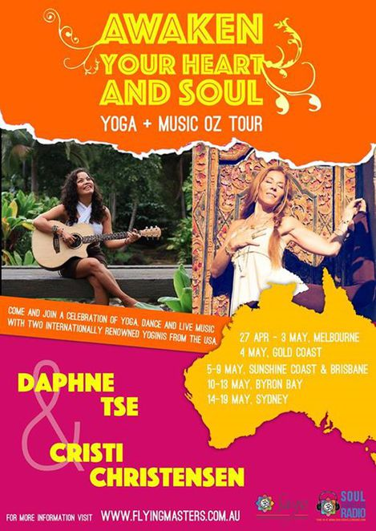
When: Multiple dates across Oz from April 27 until May 19
Phone: 9939 6210
Website: www.flyingmasters.com.au. https://www.facebook.com/events/818531708221453
Cost: All shows separately - $55.00 1 day pass - $150.00 2 day pass - $280.00. Tickets for single workshops range from $25 - $50.
SQUIZZY TAYLOR’S BALL!
When: 16th May 2015 - from 7.30pm
Website: Facebook.com/popupeventsmelbourne
Where: Collingwood Town Hall, 140 Hoddle Street, Collingwood
Cost: $49.00


You’ll find JP trying to get into this, catching up with all her old friends from the 1920’s. I believe her nickname was ‘JUICY JOY’ Hmmph! A disgrace!
RUTHERGLEN TWEED RIDE

The 25km ride is cleverly matched with food and vintage fashion and participants readily embrace the theme by stepping out in vintage style. The Ride is interspersed with three food and wine experiences showcasing the region's produce and kicks off with brunch at the Rutherglen Wine Bottle where riders will be able to take in picturesque. A French-inspired continental brunch matched with sparkling wine varieties will send riders on their way for a day of sightseeing.
Why? Enjoy beautiful scenery and delicious produce
When: 16 May: From 10:30 am- 4pm
Website: www.highcountryharvest.com.au
Where: Rutherglen Winery
Cost: $110 per person
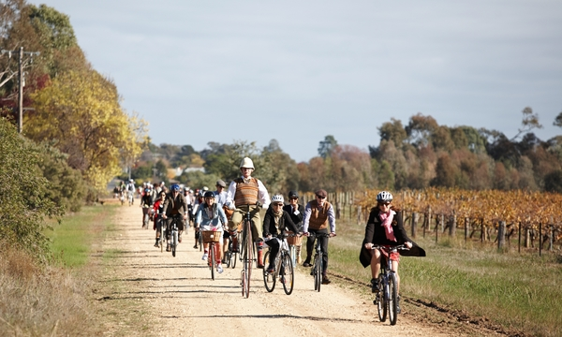

EMERGE IN THE WEST FESTIVAL 2015
Event: 16/05/2015 1-7pm.
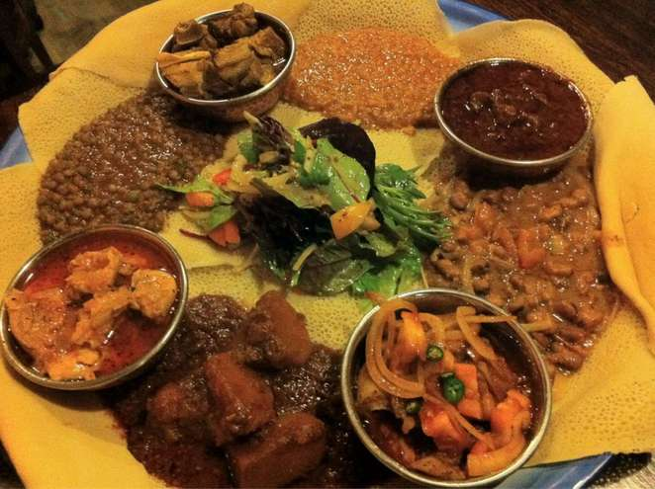
Why? Fun, interesting, cultural experience!
Website: www.multiculturalarts.com.au/events2015/emerge_west.shtml
Where: Nicholson Street, Footscray
Cost: FREE
Featuring top emerging talent from Melbourne's West, across two stages, Emerge in the West 2015 is an exciting new festival that will see Nicholson Street, Footscray come alive with African music, culinary experiences, art, fashion, crafts, textiles and more! Presented by Multicultural Arts Victoria, in partnership with Maribyrnong City Council Festival City Program,
FRESH FRUIT HAMPER GIFTS


When: Deliveries are made Monday through to Friday only
Website: www.fruitcorpfruithampers.com.au
Where: Throughout Sydney, NSW, ACT, Canberra, Gold Coast, QLD, Brisbane, VIC, Melbourne and NT
Cost: Varies
LAS TAPAS: A TASTE OF SPAIN IN MELBOURNE
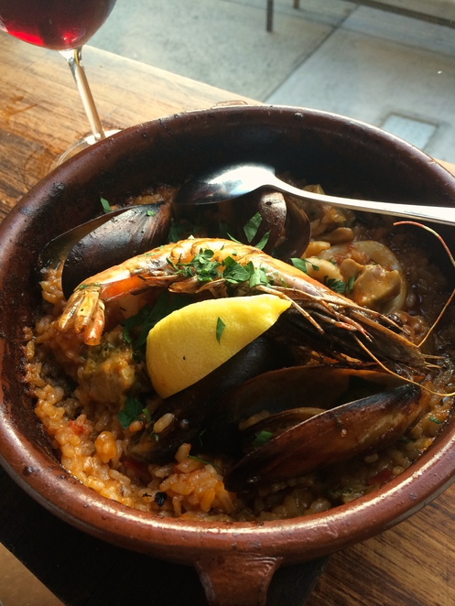
Phone: 03 9077 3969
Website: www.lastapas.com.au
Where: 100 Chapel Street, St Kilda
GO AND VISIT MOTHER NATURE!
One of Victoria's most renowned tourist destinations is the Grampians National Park, more commonly referred to as the Grampians or by the Aboriginal name Gariwerd. If you've seen what coastal Victoria has to offer (and between Wilsons Prom, Philip Island, the Mornington Peninsula, the Great Ocean Road and more, there is a lot to choose from!) maybe it's time to head inland for some killer views and a taste of country Victoria.
The park, covering 413,210 acres, is located 160 miles (260 km) west of Melbourne and 290 miles (460 km) east of Adelaide. Some ambitious travellers stop by for a day and make a beeline through all the major sights before moving on, which can work if you're low on time; however, in stretching out your stay to 2-3 days or even a week, you will not be hard-pressed to find ways to fill your days.

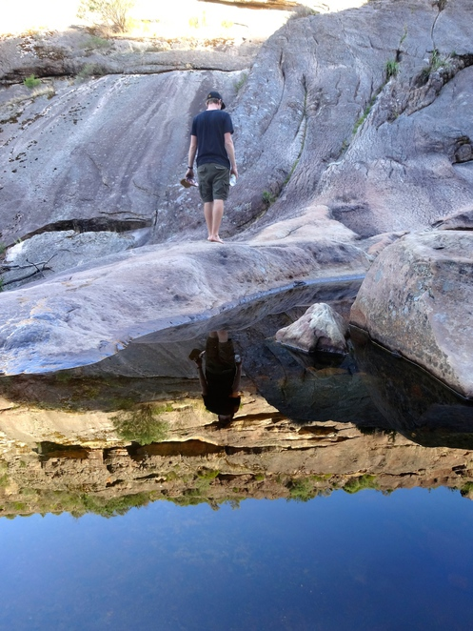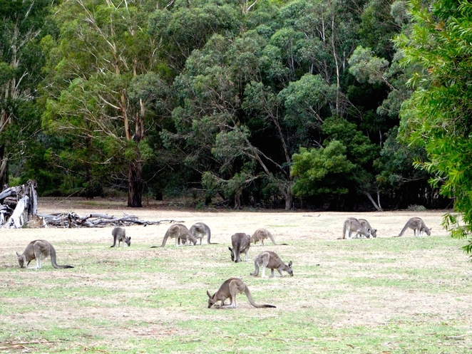

Why? Because, nature!
When: Whenever!
Where: Grampians National Park
Cost: Up to you
LIVING SUSTAINABLY IN GLEN EIRA: AN INTRO TO URBAN PERMACULTURE
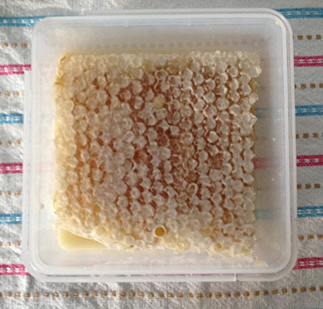
Make your own honey Learn about sustainable living practices. Do you have an interest in gardening? Would you like to grow your own vegetables or learn to keep your own bees? Well, why not try out the Permaculture way?
People who practice Permaculture are interested in reducing their ecological footprint and developing a varied healthy lifestyle, which includes creating healthy soil, and an abundance of produce.
Why? To learn about permaculture and sustainable living
When: Sunday, May 10, 2015
Website: www.permacultureday.org/event/sustainable-living-in-glen-eira
Where: Caulfield Primary School
Cost: Free!
COONARA COMMUNITY HOUSE:

Coonara Community Garden
Coonara staff, students and volunteers from the local community have been working in our community garden. Planning took several months and the vital tasks of planting began. The garden has continued to evolve and change during the seasons.
Some fresh produce has been available for picking including some delightful herbs that continue to grow after 'pruning' by Coonara house visitors and members.
Coonara volunteers have been involved in beautifying the area with mosaics and individual art works.
If you would like to be involved in the garden, please contact us - 9758 7081

Volunteer Training Program
The reception area at Coonara is staffed by volunteers, who work in conjunction with the co-ordinators to attend to the many essential tasks.
Volunteers can develop skills and learn to use a range of office systems and equipment.
If you think you would like to join our team of volunteers then speak to one of our co-ordinators today.
Areas covered include:
- Telephone skills
- Taking enrolments
- Receipting of payments
- Filing
- Word processing
- Desktop publishing
- Data entry to a variety of computer programs
- Sending and receiving email
- Internet searching
- Using fax machine, answering machine, binder and guillotine
Volunteers are rostered either on a morning shift 9.30-12.30am or afternoon 12.30-3.30pm.
We are also looking for a volunteers to help with general garden maintenance around the house which may include planting, weeding, watering etc. If you can help please call Tracy - Volunteer Coordinator - 9758 7081.
MOUNTAIN DISTRICT LEARNING CENTRE
Phone: 97587859
Fax: 97580903
Email:
Address: 13-15 The Avenue Ferntree Gully 3156

Understanding Mental Health: An event to talk about mental health is being planned for Wednesday 3 June at 7pm. Please check back for more details.

Special Interest Groups

Crafty Ladies Come along and meet the wonderful Crafty Ladies! This friendly group are looking for new members to help them create special gifts for the children of Berry Street. If you enjoy sewing, patchwork and craft activities and have some time to spread a little joy in a child’s life at a time of need, then this is the group for you.
Day & Time: Tuesday &/or Friday 9.15am to 3.00pm
Commencing Feb 3
Fee: $5.00 per day or $2.50 for a half day

Sit & Sew Would you like to join a small, friendly group of stitchers who meet to share ideas. We work at our own pace on our own projects. Anything from embroidery & patchwork through to knitting & crochet. There are no lessons, just a relaxing time of stitching & chatting with like minded ladies.Thursday mornings during school terms from: 10.00am to 12.00pm
Commencing Feb 5

Mountain Treasures Craft Group Express your creativity and share skills in this friendly group environment.
Day & Time: 1st Wednesday of the month 10.00am to 12.30pm
Commencing Feb 4

CAE Book Group Are you a book lover? Do you love to dissect the story and share your conclusions? If so, then this small, friendly group of like-minded bookworms is just right for you.
Day & Time: 3rd Tuesday of each month, commencing Feb 17
from 1.00pm to 3.00pm
Fee: Course fee to be advised at time of enrolment
New Members Welcome!

Plato and Biscuits - Philosophy Interest Group The group meets each week to participate in challenging and stimulating discussion on some of the ideas of prominent philosophers, past and present and to look at current issues from a philosophical perspective.
Day & Time: Fridays at 9.15am to 11.45am
Fee: $5.00 weekly

Ferntree Gully Singing Group Join this friendly group with an experienced tutor. Learn to sing in harmony, improve your singing skills and just have fun!! All welcome.
Day & Time: Mondays at 1.30pm
Fee: $5.00
Venue: Ferntree Gully Uniting Church
The Avenue, Ferntree Gully

Community Garden Our community garden is accessible for everyone and has hi-rise garden beds. Grow some vegies, visit the chooks or just enjoy our garden space with friendly people.
Thursday 10.00am to 3.00pm
Commencing February 5
Every week during school terms
If you would like to join in call Rachel on 9758 7859

Workshops

Moments of Rest - Paper Collage Workshop Do you find yourself rushing from one thing to another and feel like a hundred things needs to be done and everyone wants something from you? Well these quiet workshops provide contrasting time of rest and relaxation that is just for YOU! Paper collage is a creative activity that anyone can engage in - you don't need to be an artist. So set time aside for yourself and allow yourself to just ''be''. Choice of two workshops, or come to both!
Days: Thursdays 10.30am 12.30pm
21st May or/and 11th June
Fee: $20.00 per workshop plus $5 for materials

Art Class for Everyone Expression of Interest being taken for term 3. Develop or/and build upon your artisitc skills by experimenting with paint, colour and design. Paint and draw for spontaneity, creativity and fun! Lose yourself in design and free yourselves from wordly pressures. Whether you're a beginner or have some experience with drawing and painting, everyone is welcome to join our brand new Art Class in Term 3 to start YOUR journey of discovery!
Call the office on 9758 7859 and leave your details.
Adobe InDesign This course will introduce you to the basics of this powerful layout program preferred by graphic designers.
Wednesdays 7.00pm to 9.00pm
May 6th to June 24th
Fees: $70 (Tuition $35
Resources $25 Amenities $10)
Computer knowledge required.

Adobe Photoshop Learn how to use the software the professionals use to touch up and repair photos, remove objects, combine photos, change
colours of elements in an image, enhance photos and more.
Thursdays 7.00pm to 9.00pm
May 7th to June 25th
Fees: $70 (Tuition $35
Resources $25 Amenities $10)
Computer knowledge required.
Digital Literacy for Seniors
Broadband for Seniors Join Lillian and take your time to become more familiar with computers. Find out how to use email, the internet and more, in a relaxed environment in your own time and with the company of others.
Thursday and Friday 3.30pm to 5.30pm
There are computers available to all seniors in the community
at MDLC and volunteer support tutors are available at
selected times. Call MDLC
to register your interest.

Digital Seniors – Digital literacy training for seniors 65+ Flexible training to assist in communicating on-line including:
• Health information
• Making bookings and appointments
• Communicating with family and friends via email, skype,
facebook, etc.
• Searching timetables, directories, travel maps and directions
• General internet browsing
Phone Coonara Community House
for bookings on 9758 7081
Leisure Courses
Chill Out and Relax! Have you always wanted to try gentle Yoga, relaxation and meditation? Well this class is a once-off try out class, Ideal for bodies of all shapes, sizes and ages. Modifications are given for those with injuries and/or illness. Absolute beginners Welcome! We recommend this class to anyone who are seeking ways to ease Anxiety, stress, insomnia, post-traumatic stress and/or to simply improve your General health and well-being. Bring a yoga mat, pillow, water bottle – and wear loose comfortable clothing.
Saturday 1.30pm to 3.00pm
23rd May
$25 per person
Soapmaking with Sharnn Beautiful Natural Olive and Coconut Oil Soap Making Workshop. Learn how fun and easy it is to make your own soap using easy to find ingredients. All materials supplied
and you get to take home approx 600ml of soap we make in the workshop. About 5 or so bars of beautiful, natural soap!! Bring some essential oils if you would like and an empty 1 litre cardboard milk carton.
Individual workshops: Saturday 23rd May or 30th May
10.00am to 12.00noon
$35 plus $5 materials to tutor on the day

A Beginners Course in Crochet Our friendly tutor Lynda will teach you the fundamentals of crotchet including the ever popular granny squares! This is your chance to pick up a new craft, delving into special
techniques and resources in a friendly, relaxed setting. BYO 4mm Crochet Hook and 8 ply yarn – colours of your choice.
All ages welcome!
Saturdays 10.00am to 12.00noon
2nd May to 6th June
$60.00

ORANA NEIGHBOURHOOD HOUSE
62 Coleman Road
Wantirna South VIC 3152
Open Monday - Friday 9.00am - 3.00pm
Tel: 9801 1895 Fax: 9800 3192
onh@netspace.net.au
www.orananh.org.au

Support Groups

Bounce Back Women's Group Creative ways of dealing with Anxiety & Depression
Come and join a safe and friendly group to hear from various guest speakers on social, emotional and spiritual well being. Join us on various outings and activities for relaxation and enjoyment.
Wednesdays during school terms - 1.00pm to 3.00pm
Cost: $5 each week

Groups that meet at Orana

Overeaters Anonymous A self-help group offering shared experience and mutual support to encourage recovery from compulsive eating.
Monday meetings weekly at 8.00pm - Contact: 9521 3696

GLEN PARK COMMUNITY HOUSE
Glen Park Community Centre
30 Glen Park Road
Bayswater North, Vic 3153
Phone: (03) 9720 5097 or (03) 9720 9549
Fax: (03) 9729 7857 Email office@glenparkcc.com.au
Opening Hours: Monday to Friday 9am-4pm
Glen Park Oaks Community Garden

Home grown tomatoes
Glen Park Community Centre in partnership with Maroondah City Council and the wonderful Glen Park Working Group proudly presents the Oaks Community Garden. Curved bluestone borders, meandering footpaths through delicious smelling herbs and thriving fruits and vegetables...welcome to the Glen Park Oaks Community Garden. This wonderful garden has been created and designed for the community to use and we trust that you will find your association with the garden to be a truly rewarding experience. The current members have been working hard to grow some wonderful produce including summer tomatoes, beans, zucchinis, lemons, rosemary and sage to name a few. It is a very worthwhile and rewarding experience to be part of this gorgeous community garden, not only as you are growing food for the community, it's fresh, healthy and grown with love.
The Biggest Morning Tea
Café on the Park is proud to help supportive services for cancer patients and their families by hosting the Biggest Morning Tea!
Thursday 28th May 10:30am-11:30am
Raise money to help fund world class cancer research.

Join us by bringing a plate of food and donating a gold coin.
Yummy scones, tea & coffee will be provided!
Lucky Door Prize & Raffle
1st Prize: InstaCube
2nd Prize: Hand painted porcelain plate
3rd Prize: Hamper
4th Prize: ‘Our Legends’ biography
5th Prize: Queen Quilt Cover Set
Learner Driver Mentor Program
 | L2P is a community based volunteer program designed to provide driving practice for young learner drivers who face significant barriers in gaining their 120 hours of driving practice required to obtain a probationary licence. Mentors are volunteers from the community who undertake a selection and training process to fulfill the role of supervising driver. Mentors develop a trusting and supportive relationship with the young person by providing them with the tools they need to be safe and confident drivers. Mentoring provides volunteers with the opportunity to meet new people, develop new skills and have a positive impact on the lives of young learner drivers. If you are interested please complete the Mentor Application Form and view the Mentor Handbook plus the Statewide Common Road Rules here.
GLEN PARK’S BEAUTIFUL ‘CAFÉ ON THE PARK’ 9am – 3pm Mon – Fri.
Talk about good food, ha, this place leaves Masterchef for dead, mainly because they cook beautiful food that doesn’t need 5 billion ingredients and 2 hours to cook it. Beautiful food, friendly staff and a great venue, really adds up to an excellent dining experience, yum! The menu changes seasonally, the quality doesn’t, excellent right throughout the year.
LEARN HOW TO MAKE AND BAKE SOURDOUGH BREAD (IN MANSFIELD ☹)



Why? Because everyone loves bread
When: Saturday, 23 May 2015
Phone: 0414 594 133
Website: www.mtbullersummerschool.com.au
Where: Mansfield, Victorian High Country
Cost: $125 per person (WELL, THAT IS A LOT OF DOUGH!)

BEHIND THE SCENES @ MELBOURNE MUSEUM (You’ll be able to check out JP and all the other fossils)

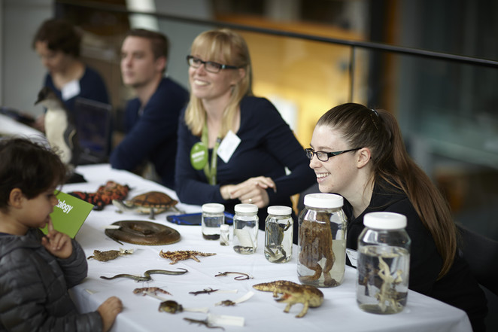
Don't miss this unique chance to see some of the rarest items of natural history held in Australia, between 10am and 4pm on Sunday 17 May, 2015. Entry into Science on Show will be open to everybody, with no extra cost on top of the usual Museum entry costs. Find out more here.

Why? A very special behind-the-scenes program
When: 10am - 4pm, Sunday 17 May, 2015
Phone: (03) 8341 7777
Website: www.museumvictoria.com.au/melbournemuseum
Where: Melbourne Museum, 11 Nicholson St, Carlton VIC 3053
Cost: Free with usual entry into Melbourne Museum

EUROVISION’S BACK! (WITH OUR VERY OWN ‘GUY’ COMPETING!)
In spite, or maybe because of, Australia's inability to vote in the competition, the culture-starved hordes of this great Southern land can't get enough of all things Eurovision. Our enthusiasm has been rewarded: Eurovision 2015 will have its first ever Australian entry.
Why? This is Australian musical history in the making - we're in Eurovision people!
When: Thursday May 21 to Sunday May 24 2015
Website: www.eurovision.tv
Where: From Vienna to Melbourne and all places in-between
Cost: €14 to €390 or free and live (another Aussie first) from the comfort of your lounge room


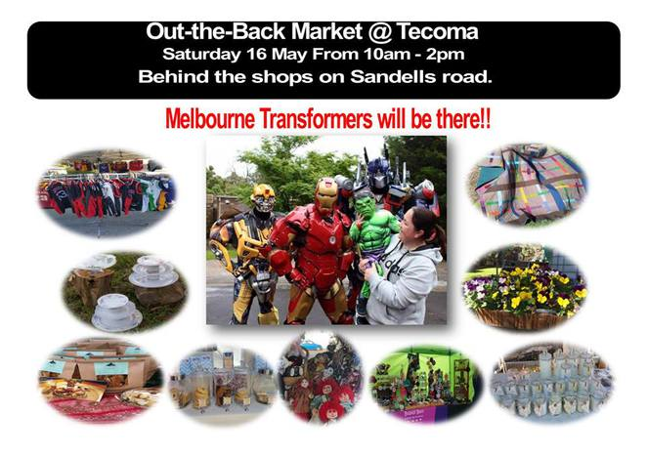
OUT THE BACK MARKET @ TECOMA:

Superheroes, Irish Dancers and a Face Painter will be visiting The Market to entertain you. Bring the kids to check out the superheroes and have photo opportunities with them.
When: Saturday 16 May 2015 from 10am to 2pm
Phone: 0417 347 541
Website: https://www.facebook.com/IndieMarketPlace
Where: Behind the shops at the intersection of Sandells Road and Burwood Highway, Tecoma, VIC
‘EAT’ STREET – VARIETY’S FUNDRAISER



AROUND THE WORLD IN 40 DISHES @ THE SOFITEL, MELBOURNE ON COLLINS

With just over two weeks to go, book your tickets now to join the fun and help raise money for Victorian children in need! Tickets are $160pp all food and drink included. Group bookings - buy 10 tickets and get the 11th free!

Why? Enjoy some of Melbourne's top restaurants for a great cause
When: From 6pm
Website: www.eatstreetmelbourne.com
Where: Sofitel Melbourne on Collins
Cost: $160 per person all inclusive

Cheers, Bigears!
Catch up next week!
Toni

