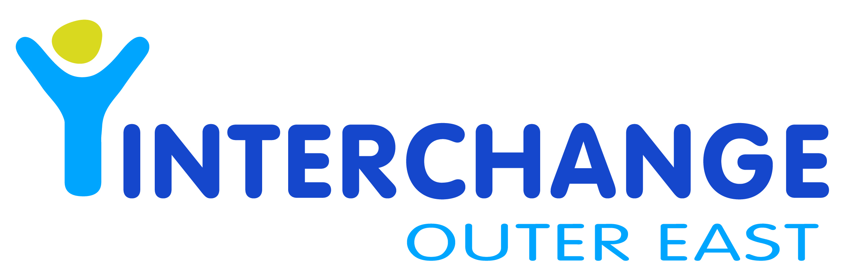

INTERCHANGE OUTER EAST
PHOTO PERMISSION FORM

I give my permission for Interchange Outer East to use and reproduce photographic and videoed material for the purpose of promotion of:
- myself (participant over 18 years/ volunteer / carer
- my child
- other family members

I agree to the use of photographic / video material in (cross out or type NO where permission is withheld):
- Interchange Outer East newsletter (*AVAILABLE ON THE WEBSITE AS A DOWNLOAD)
- posters / display board material
- In house training purposes
- Internet – Interchange Website/ Interchange linked sites and applications
- Interchange Outer East brochures / booklets / flyers
- Interchange Outer East advertisements/articles in newspapers / other publications

I am aware that I have the right to withdraw this consent (in writing) at any time.
Signed:
Print Name:
Date:
Child’s full name:

Please send completed, signed form to
Interchange Outer East, 5 – 7 Yose St, Ferntree Gully 3156
Fax to 9758 5899 or email as an attachment to ioe@ioe.org.au

